Individual Pathways
Activity 10.3 Answers
Analysing energy
- Types of energy and their sources
Complete the following table by identifying energy sources for each energy type listed.
Sources: fluorescent tube, uranium fission, chocolate bar, moving tennis ball, vibrating violin string, rubber band, battery, infra-red lamp
Energy type | Source
Chemical | Chocolate bar
Sound | Vibrating violin string
Light | Fluorescent tube
Electrical | Battery
Heat | Infra-red lamp
Elastic potential | Rubber band
Nuclear | Uranium fission
Kinetic | Moving tennis ball
- Types of potential energy
Categorise each of the types of potential energy shown in the table below.
Example | Category of potential energy
Air brakes in a truck | Elastic
Wound watch spring | Elastic
Kerosene | Chemical
Sugar | Chemical
Depressed trampoline canvas | Elastic
Comet | Gravitational
Parachutist at the point of launch | Gravitational
- Objects of various masses (m) are raised from ground level to various heights (h) above the ground in a gravitational field. The following data was collected.
Mass: m (kg) | 5 | 5 | 5 | 5 | 10 | 20 | 40
Gravitational acceleration: g (m/s²) | 9.8 | 9.8 | 9.8 | 9.8 | 9.8 | 9.8 | 9.8
Height: h (m) | 2 | 4 | 6 | 8 | 4 | 2 | 1
Gravitational potential energy: GPE (J) | 98 | 196 | 294 | 392 | 392 | 392 | 392
The formula for gravitational potential energy is: GPE = mgh.
- Using the formula given above, calculate the GPE for each column.
- Generate a scatter chart graph of GPE versus h in the space provided below. Complete the graph by inserting labels on each axis and an appropriate title.
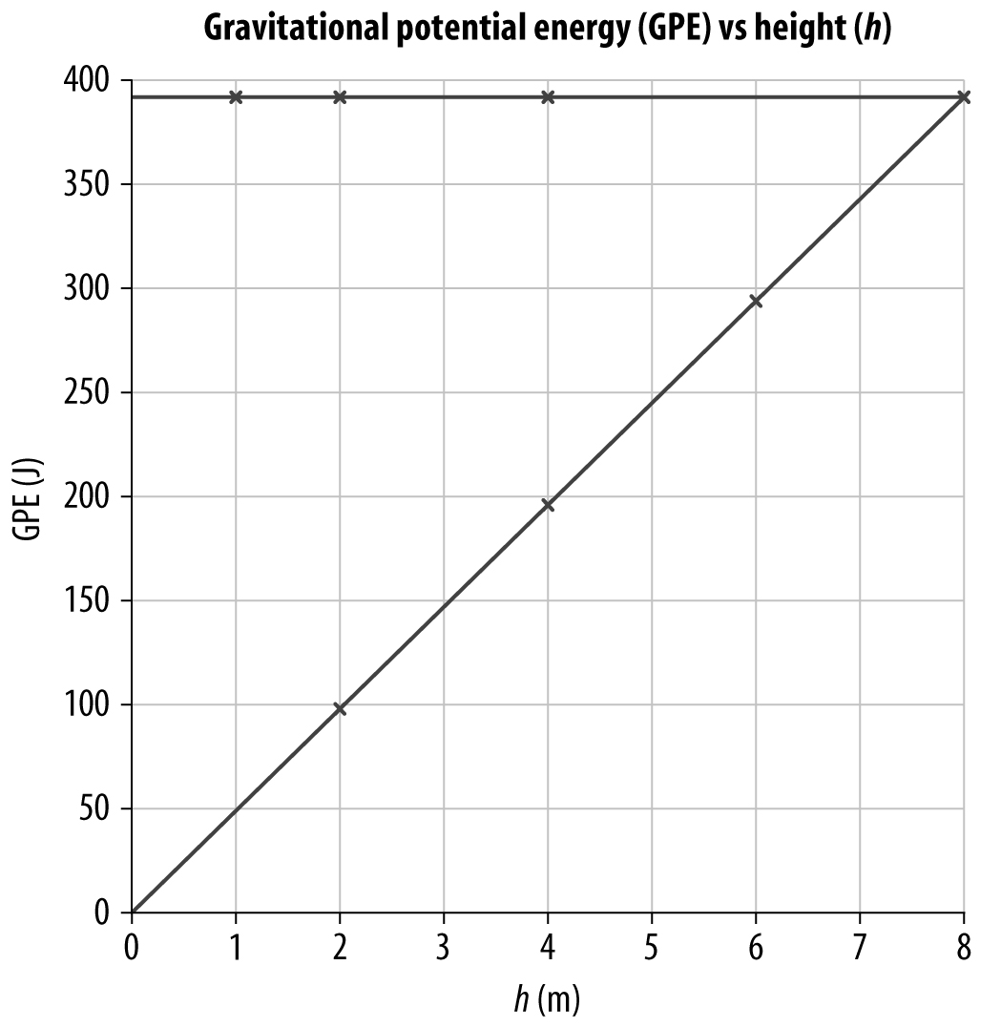
- Outline the shape of this graph.
Linear. There are two lines.
- Describe how GPE changes for a fixed mass as it is raised to increasing heights above the ground.
GPE increases as height increases.
- Examine the data in the last four columns. Identify how the mass changes.
The mass doubles from one column to the next.
- Identify how the height changes.
The height is halved from one column to the next.
- Describe how these two changes affected GPE.
There is no change to GPE.
- An object of mass 10 kg is dropped from a stationary point 100 m above the ground, as shown below.
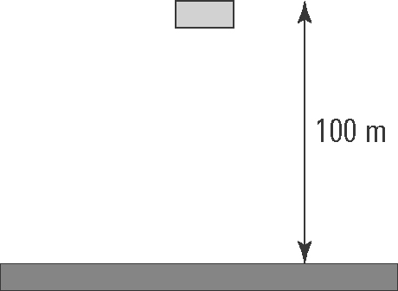
At any point during the fall, the object has gravitational potential energy (GPE) and kinetic energy (KE) given by the formulae:
GPE = mgh and KE = mv²
where m = mass (kg), g = 9.8 m/s², h = height (m) and v = speed (m/s).
- Use these formulae to complete the following table:
h (m) | GPE (J) | v (m/s) | KE (J) | GPE + KE (J)
100 | 9800 | 0 | 0 | 9800
90 | 8820 | 14.000 | 980 | 9800
80 | 7840 | 19.799 | 1960 | 9800
70 | 6860 | 24.249 | 2940 | 9800
60 | 5880 | 28.000 | 3920 | 9800
50 | 4900 | 31.305 | 4900 | 9800
40 | 3920 | 34.293 | 5880 | 9800
30 | 2940 | 37.041 | 6860 | 9800
20 | 1960 | 39.60 | 7840 | 9800
10 | 980 | 42.000 | 8820 | 9800
0 | 0 | 44.272 | 9800 | 9800
- Outline how GPE changes during the fall.
GPE decreases.
- Outline how KE changes during the fall
KE increases.
- Outline how the sum of GPE and KE changes during the fall.
There is no change in the sum of GPE and KE.
- Convection
Consider the following illustration showing the movement of air near the ocean shore. Describe how the production of convection currents makes the climate near the coast milder than it is inland.
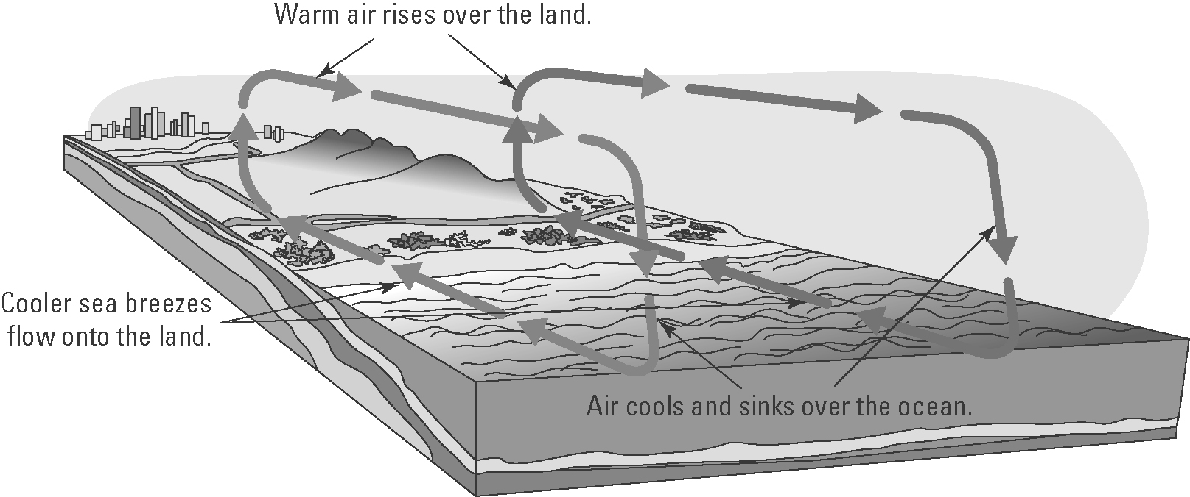
Warm air rises over the heated land and is replaced by cooler sea breezes flowing off the sea. This sets up a convection current in which the warmer air at a higher altitude flows towards the coast, where it sinks as it cools. This means that coastal climates are cooler as the sea breezes are cooler.
- The diagram shows an incandescent light bulb.
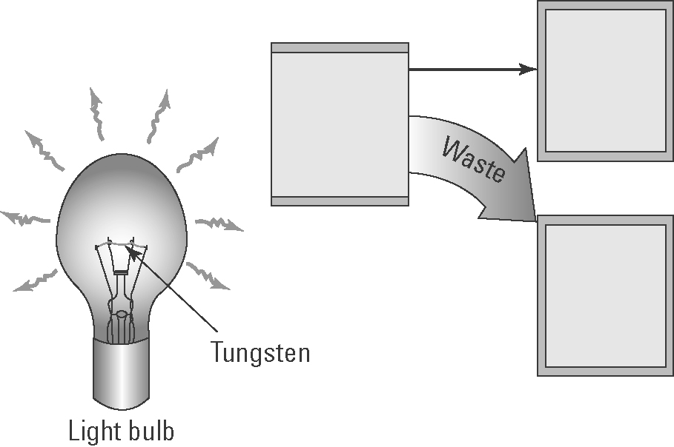
- Explain how an incandescent light bulb generates light.
Incandescent light bulbs contain a filament made of tungsten that is luminous or glowing due to the high temperature of the wire as the current flows through it.
- Insert the following words in the boxes in the diagram: heat energy, electrical energy, light energy
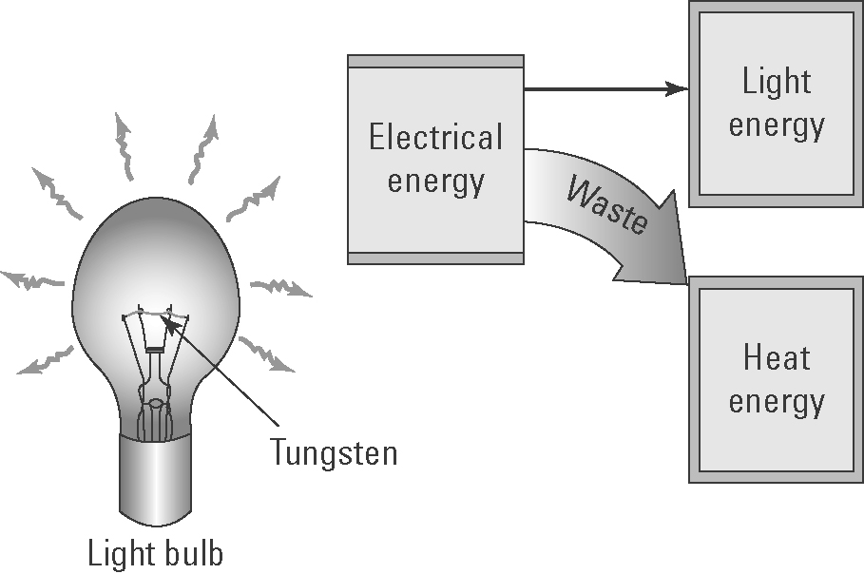
- Explain why incandescent light bulbs are not energy efficient.
They are not energy efficient as most of the energy released as heat rather than light.
- The diagram below shows the procedure used by a student to measure the intensity of reflected light from various materials and compare it with light reflected by a normal mirror.
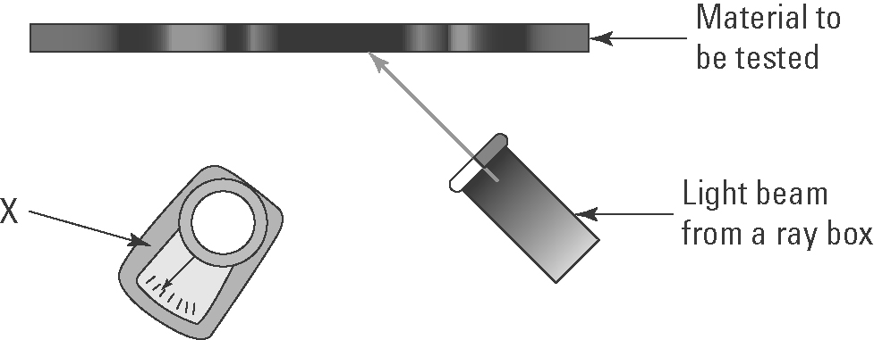
(a) Identify the measuring device X.
Light meter
(b) Why is a normal mirror also tested?
It acts as a control to allow a comparison with the other test materials.
(c) Identify the variables that need to be controlled.
Distance of light source from the materials to be tested; angle of light incident on the material; the light meter; ambient light
(d) The following materials were tested: shiny white cardboard, dull black cardboard and shiny black cardboard. Predict which cards will reflect the:
(i) most light energy?
Shiny white cardboard
(ii) least light energy?
Dull black cardboard
- Wavelength and frequency
The following diagram shows two vibrating tuning forks producing sound waves.
A | 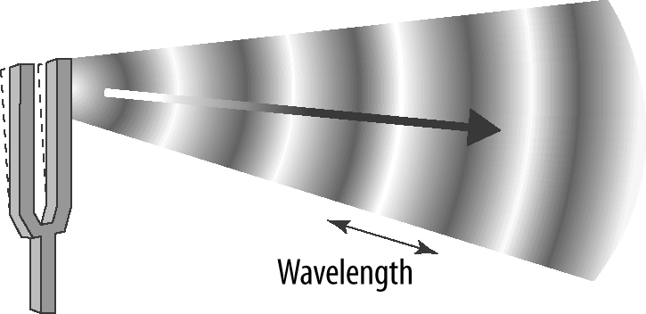 | (a) Identify the features of the wave labelled X and Y.  X: rarefaction  Y: compression
B | 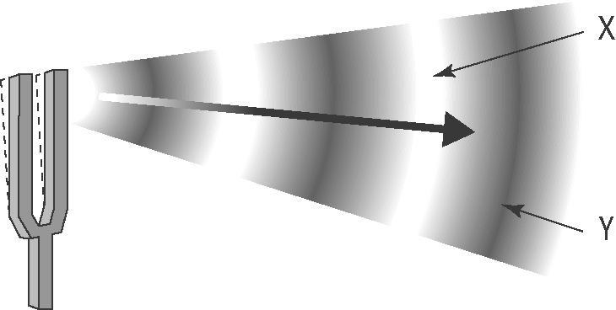 | (b) Which tuning fork produces sound waves with the lower pitch? Explain.  B has the lower pitch (or frequency) as its wavelength is greater.

- Speed of sound in water
The following graph shows how the speed of sound (in m/s) in water varies with temperature (in °C).
(a) The labels and units on each axis are not shown. Insert these labels and units.
(b) Give the graph a title.
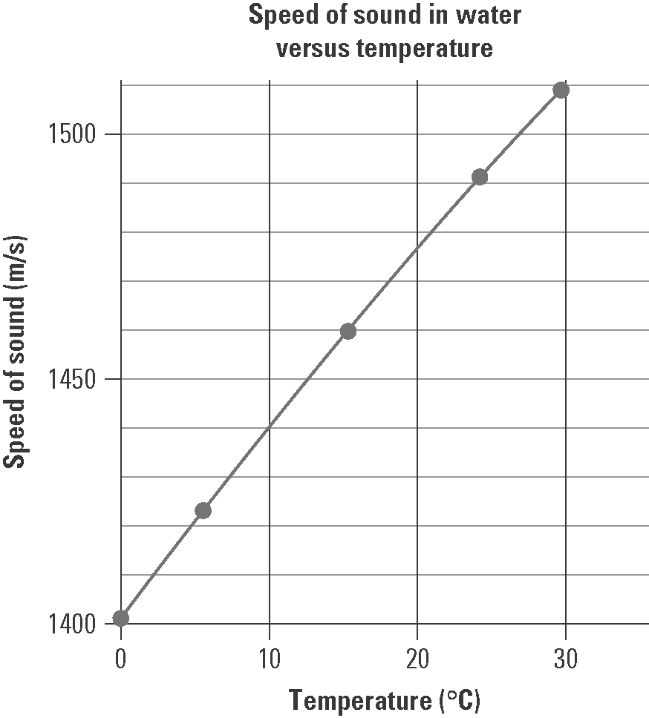
(c) Use the graph to determine the speed of sound in water at:
(i) 0 °C 1405 m/s
(ii) 10 °C 1440 m/s
(iii) 20 °C 1475 m/s
(d) In air, the speed of sound at 0 °C is 331 m/s.
(i) How many times faster does sound move in water than air at that temperature? (Hint: Divide one speed by the other.)
. Therefore, sound moves more than four times faster in water.
(ii) Explain why sound moves faster in water than in air.
The sound moves faster in water than air as the particles are much closer together and so collisions occur more frequently and thus the energy is passed on to the next particle more quickly.

